This is the current screen in the current sales app, we need to grab that code and make some edits. We don’t have access to this in a live environment so I can’t get a better shot ☹

Resident: Stella Smith (update med record number)

Facility: Update

User: Update

Remove the assessment version and date from end of the evaluation name





Remove the word - Metric

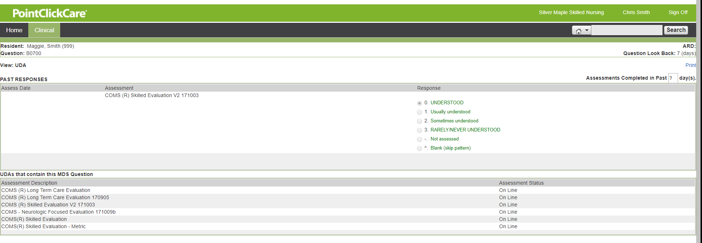

Screen 2: Pie Graphic (TBD)

Screen 3: PDPM ICD-10 codes

Screen 4: Soft Required (TBD)

Screen 5: Summary Page Graphic (TBD)

Hyperlink Doc for Info button: List of MDS and what is covered (TBD)